Release of Liability
I, __________________________________________________, release Stacey Davenport/Pig Pen Hill Mini Pigs, here by known as seller/breeder, from any medical liability pertaining to pig(s) described below:
Name: ___________________________________________ Microchip #:__________________________________________
DOB: ____________________________________________ Color/Marking: ______________________________________

Pig described above was seen by our attending veterinarian on ________/_______/_______ for spay / neuter.
Buyer Agrees:
- He/she was given the option to allow my breeder to hold above listed pig(s) to have staples/stitches removed before gaining ownership for an additional fee of $50.00. ___________(buyer’s initials)
- By choosing to take ownership before stitches/staples were removed, he/she waives the right to pursue any liability that occurs pertaining to procedure mentioned above. I agree that surgical site is clean with no signs of infection; including but not limited to any drainage, redness, swelling, and/or foul odor. __________(buyer’s initials)
Pig Pen Hill Mini Pigs  16124 Linton Rd.  Cadiz, Kentucky 42211  270-350-7371  pigpenhill.minipigs@gmail.com  www.pigpenhillminipigs.com | 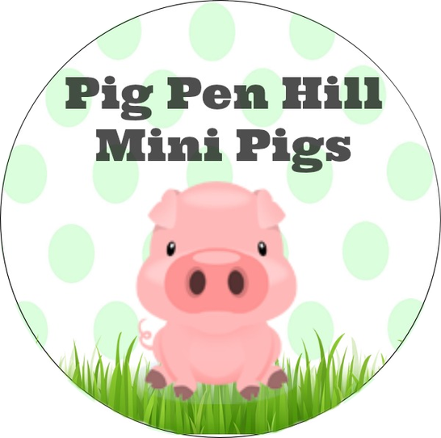

By signing this document I agree to see my personal veterinarian for an initial vet visit as well as have staples/stitches removed in a timely manner. I also take sole responsibility for any and all expenses occurring after I have left breeder’s property.
Buyer’s Signature: _______________________________________________________________________________________
Date: ______________________________________________________________________

